Secret Six CTMS User Manual

1. **Login/Logout**
   1. Once accessing the URL for the Secret Six CTMS, you will be brought to the Login page. Input your login information and click the green login button. To logout, click the ‘logout’ button to be taken back to the login screen.

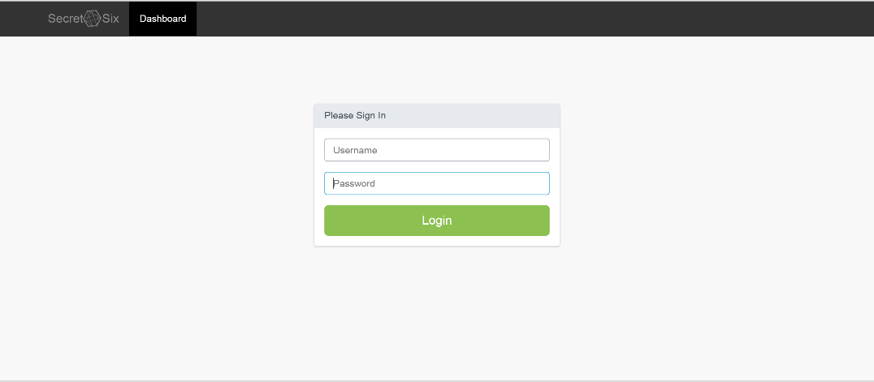

1. **CRN View**
   1. **CRN - Login**
      1. To login as nurse, use username: CRC and password: crc.
   2. **CRN – View Studies**
      1. Click ‘View Studies’ to reveal the following studies/charts: All Studies, Number of Patients Assigned per Study, Study Success Rate Report, Weight Study Real vs Placebo, Sleep Study Real vs Placebo, and Height Study Real vs Placebo.

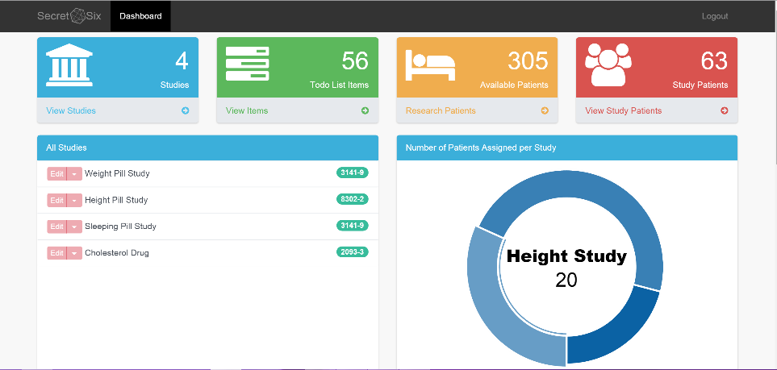

* 1. **CRN – Todo List Items**
     1. Click ‘View Items’ to access the Todo List Items pane. Listed will be all patients under each of the four studies (Weight pill, Height pill, Sleeping pill, Cholesterol drug). Click the green bar for each study to expand the list and view all patients. You may also begin typing in a patient’s name in the ‘Search’ field to display only the studies in which that patient is present.

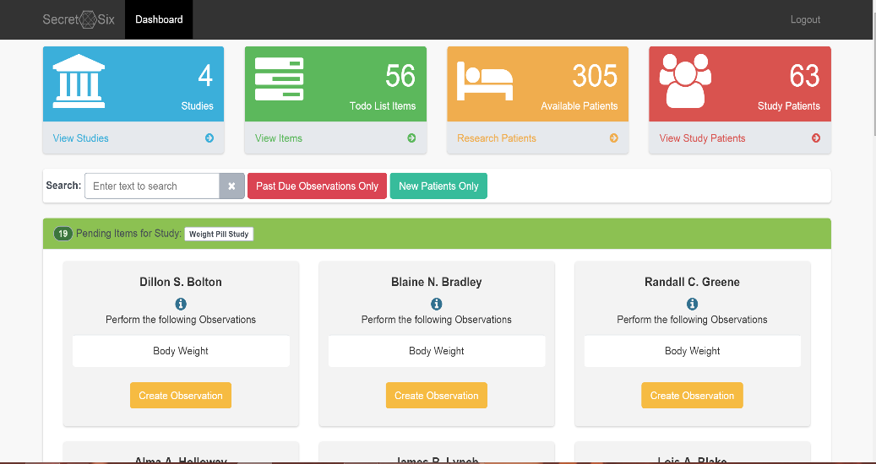

* + 1. **Create Observation**
       1. To create a Patient Observation, expand a Study item and click the orange ‘Create Observation’ button.
       2. Click the blue ‘Create a new observation’ button at the top of the pop-up screen then enter in all required information and click ‘Add’.

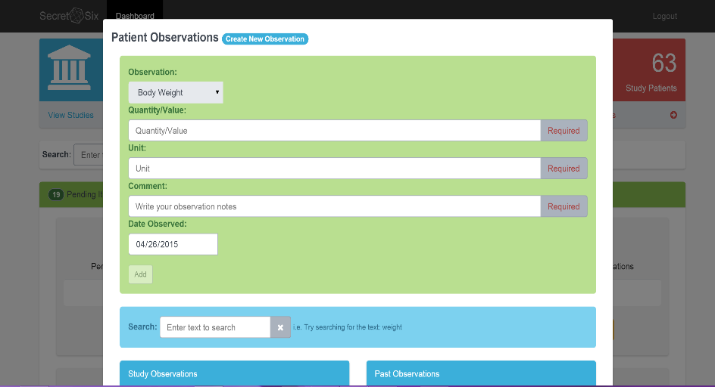

* + - 1. After you are done with adding observations, click the ‘Close’ button.
  1. **CRN – Available Patients**
     1. Click the ‘Research Patients’ button to access the list of available patients. Note that this sections contains patients from the provided dataset so they are already in the database and cannot be added or ignored.

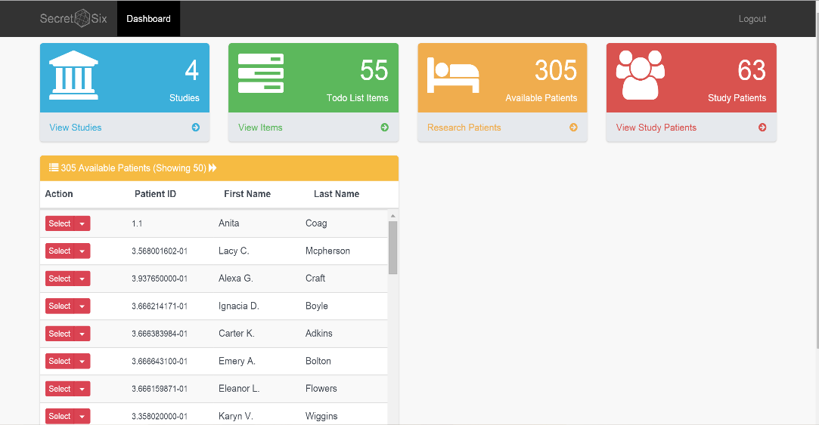

* 1. **CRN – View Study Patients**
     1. Click the ‘View Study Patients’ button to access the Study Patients list. Patients can be searched from this list also and observations can be added by clicking the ‘Observations’ button.

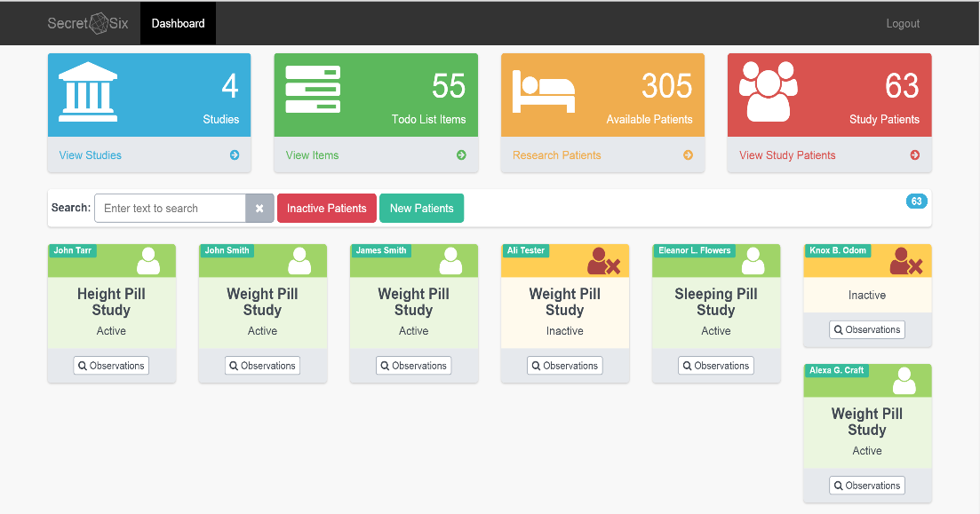

1. **Sponsor View**
   1. **Sponsor – Login**
      1. To login as sponsor use username: Sponsor and password: sponsor.
   2. **Sponsor – View Studies**
      1. Once logged in as Sponsor, please note that only the ‘View Studies’ and ‘View Study Patients’ are accessible.

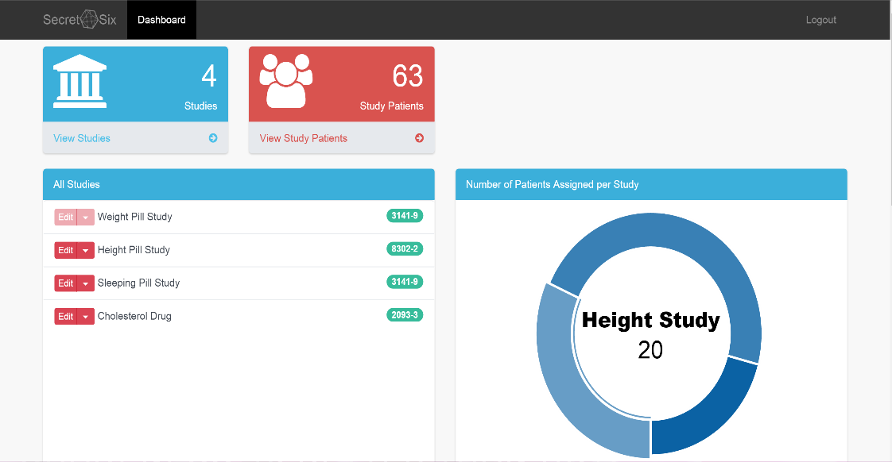

* + 1. The same charts and fields from the CRN view are available. However, as a sponsor, you are able to mark studies as complete. Once a study is marked complete, it will be grayed out as shown in the diagram above.
  1. **Sponsor – View Study Patients**
     1. Click the ‘View Study Patients’ button to view the list of Study patients. Click the ‘observations’ button under a patient to view the observation. Not that the ‘Create a new observation’ button is not visible.

